Software requirement specification for project OMG (oh my gene)
201732120167
Thero Teto Clive

Introduction
The software requirement specification for the project (oh my gene)

Properties
- Client User: Biologists who devote themselves studying the expression of genes.
- Site Maintainer: Technicians who have the basic knowledge of flask and python to maintain a website.

Terminologies & Abbreviations

To introduce the project and specify the requirements in detail, this section is aimed to explain some terminologies and abbreviations, for the sake of better understanding of the content of the project.

Terminologies

Control sample - A cell sample prepared in its normal condition.

Treatment sample - A cell sample treated by special chemicals, or in which some genes is altered.

Differentially expressed genes - The genes which have significantly different expression levels between two samples.

Up-regulation - A gene is said to be up-regulated if it has higher expression in treatment than in control.

Abbreviations

OMG - Oh My Genes, which is the name of this project.

LogFC - log fold change of gene expression. log_2 [T/C], where T is the gene expression level from a treatment sample, while C is the gene expression level from a control sample

Overview

The remainder of the document is organized as follows: section two provides a general description and functionality of the web application and section three provides non functionality

Overall Description

Functional requirement
In order to make the software work very efficiently we shall respect certain conditions while computing with the data such as the (choose file) button:
It is a TAB-delimited, plain text file with three columns;
The file contains an optional head line, followed by each gene’s expression in a control sample (e.g., Control Sample) and in a treatment sample (e.g. Knockout Sample).

Gene express txt2

AT1G01010 1.198558083 2.036161827

AT1G01020 13.75736234 13.370796

AT1G01030 0.833779536 0.203616183

AT1G01040 9.58846466 7.126566394

AT1G01046 0 0

AT1G01050 23.81482799 21.10821094

AT1G01060 0.625334652 1.221697096

AT1G01070 1.719670292 0.950208853

AT1G01080 28.34850421 25.24840665

AT1G01090 58.26034505 42.96301455

AT1G01100 1066.508249 1308.030358

AT1G01110 2.709783491 1.425313279

AT1G01120 51.32955266 44.32045576

AT1G01130 1.094335641 0.814464731

AT1G01140 18.1347049 15.20334164

AT1G01150 0.104222442 0

AT1G01160 21.93882403 20.09013002

AT1G01170 43.35653585 36.58304082

AT1G01180 2.13656006 5.022532506

AT1G01183 0 0

AT1G01190 4.064675236 3.732963349

AT1G01200 0.729557094 0.135744122

AT1G01210 4.950565993 6.787206089

AT1G01220 5.523789424 4.818916323

AT1G01225 1.459114187 0.950208853

AT1G01230 21.73037915 20.15800209

AT1G01240 37.36374544 25.99499932

AT1G01250 12.24613693 4.072323654

AT1G01260 3.126673259 4.411683958

AT1G01270 0 0

AT1G01280 0 0

AT1G01290 7.504015821 6.04061342

AT1G01300 42.88753487 43.50599103

AT1G01305 0 0

AT1G01310 0 0.135744122

AT1G01320 154.7182151 114.771655

AT1G01335 0 0

AT1G01340 2.761894712 2.104033888

AT1G01350 8.702573903 9.026984099

AT1G01355 0.104222442 0

AT1G01360 7.191348495 6.379973724

AT1G01370 5.054788435 4.411683958

AT1G01380 2.032337618 2.511266253

AT1G01390 0.833779536 0.475104426

AT1G01400 0 0

AT1G01410 0 0

AT1G01420 2.970339596 2.30765007

AT1G01430 28.50483788 16.69652698

AT1G01440 5.367455761 5.361892811

AT1G01448 1.04222442 0.407232365

AT1G01450 0 0

AT1G01453 0 0

AT1G01460 0 0

AT1G01470 245.8086294 129.7713804

AT1G01480 3.69989669 1.357441218

AT1G01490 35.64407515 28.84562588

AT1G01500 32.46529067 24.50181398

AT1G01510 38.92708207 33.3251819

AT1G01520 0.052111221 0.475104426

AT1G01530 0 0

AT1G01540 12.03769205 10.72378562

AT1G01550 95.15508951 91.15217778

AT1G01560 5.523789424 7.194438455

AT1G01570 0.469000989 0.814464731

AT1G01580 0.677445873 0.203616183

AT1G01590 0.208444884 0.067872061

AT1G01600 1.61544785 1.900417705

AT1G01610 21.88671281 16.56078286

AT1G01620 228.6119264 204.3627754

AT1G01630 12.71513792 9.977192951

AT1G01640 0.469000989 0.950208853

AT1G01650 11.46446862 7.330182577

AT1G01660 1.04222442 0.203616183

AT1G01670 2.084448839 3.122114801

AT1G01680 11.09969007 8.551879673

AT1G01690 1.459114187 1.28956

Gene Expression 1

Gene id | Control Sample | knockout Sample
AT1G01010 | 1.198558083 | 2.036161827
AT1G01020 | 13.75736234 | 13.370796
AT1G01030 | 0.833779536 | 0.203616183
AT1G01040 | 9.58846466 | 7.126566394
AT1G01046 | 0 | 0
AT1G01050 | 23.81482799 | 21.10821094
AT1G01060 | 0.625334652 | 1.221697096
AT1G01070 | 1.719670292 | 0.950208853
AT1G01080 | 28.34850421 | 25.24840665
AT1G01090 | 58.26034505 | 42.96301455
AT1G01100 | 1066.508249 | 1308.030358
AT1G01110 | 2.709783491 | 1.425313279

Output

Chart results
Gene Expression 2
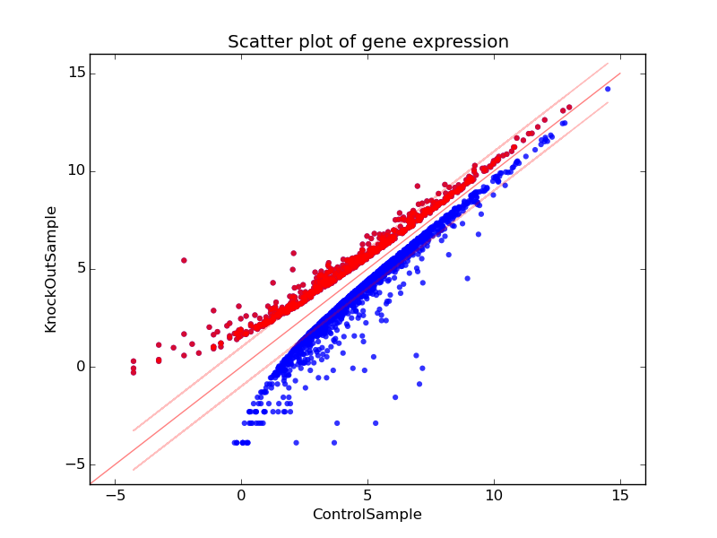

Constraints

The user who is using this application is orientated to various users who are also using the same software. Even before a development the project, some main constraints have to be taken into account so that we can come up any useful ideas to deal with them in the future.

Webpage Compatibility

Because the application is used for a wildly verity application, it should be compatible with many browsers like it should be accessible through Firefox, Chrome, and Safari.

Size

The speed should not be the only thing to be considered but also the size. There are two aspects for size. One is the size of the whole web application. The aspect, when the application starts working, the memory must occupy a certain limited under a certain level to make sure the system work in a proper way.

Budget

Budget less than 20 000 yuan

System Repaired and updates

In Events the system crashes it should be fix between 1 hour to a 1 day and constant update to improve the visual design of the system.

Non-functional Requirements.

Response Time

Since this web page is used all around the world, the server maybe have to stand a heavy load of requests thus may cause some problems such as the system will down for several times or lose response to its clients. For the optimization aspects, our algorithm should be sufficiently effective to deal with this situation. After discussion, we have decided the limit of response time; it should less than 5 seconds for the most using cases.

Aesthetic Aspects

The web page solves multiple biological analyzing. The interface has to be easy and simple for anyone to use

Confidentiality Policy

As this is a public web page, security has to be a significant part to be considered. Especially for users who want to keep their data confidential.

Change Cases
Can be more compatible that as txt file.
Downloading the outputted data will be supported in the long run
More functions will be provided from the application.

Milestones
Submit SRS for review by March 27st.
Get SRS approved by April 3th.
Get design done by April 10th.
Get coding done by May 16th.
Acceptance tests by May 27st.
Release by June 5th

Appendices
Date | Change Log
April 26th | - Specified basically functions and interface for the application.
April 26th | - Get non-functional requirements in detail.
April 26th | - Clarified some constrains about the application.
April 26th | - Imagined some change cases and tried to find ways to solve them.
April 26th | - Decided the project developing milestones.

Refences

SRS part ten (http://omg.lanlab.org/)

